Inside the Vault — Senior Management Report
October 2026 · @KAMALPREET SINGH

Purpose and scope
This report translates the technical assessment "Inside the Vault" into the decisions leadership needs to make: what was tested, what gaps it exposed, and what it takes to close them.
The work was a controlled lab exercise, not a live incident. A single Windows Server 2022 host ran in an isolated virtual network with no link to production or corporate systems. The assessor deliberately switched off the server's own defenses to test whether the host could still detect an intruder once prevention had failed.
Why it matters: the gaps shown here — defenses an administrator can turn off, executables that run from any folder, outbound traffic no one filters — exist on most unhardened Windows servers. The exercise shows both the exposure and that built-in monitoring can still catch an attacker after prevention is gone.
- Target: one Windows Server 2022 host, isolated lab, October 2026
- Framework: NIST SP 800-115, mapped to MITRE ATT&CK and NIST SP 800-53 Rev. 5
- Out of scope: production systems, cloud, denial-of-service, persistence

Findings at a glance
The exercise exposed four control gaps and confirmed two controls working. Two gaps are critical: once an administrator can disable the server's defenses, nothing automatic stops a standard attack.
# | Finding | Rating | Action
F-02 | Endpoint prevention fully disabled — Defender real-time and tamper protection, all three firewall profiles | Critical | P1 — Immediate
F-04 | Reverse shell (C2) established outbound on a non-standard port, unfiltered | Critical | P2 — Short-term
F-03 | Any executable can run from user-writable folders (Downloads, Temp) | High | P1 — Immediate
F-06 | Attack used commodity tooling, not a novel threat — 47 of 71 engines flagged the file | Informational | Monitor
F-01 | Integrity-hashed configuration baseline captured across 10 system areas | Worked as intended | —
F-05 | Built-in host telemetry caught the intrusion with no third-party EDR | Worked as intended | —

Business risk and compliance exposure
In production, the two critical gaps chain into full server takeover: an attacker who lands a file and disables defenses gains an interactive foothold, then moves laterally and exfiltrates data. The server's outbound call to the attacker went unfiltered — the same path real malware uses to reach its operator.
Were this configuration present in a regulated production environment, it would breach controls in frameworks the business is likely bound by:
- ISO/IEC 27001 — A.12.1.2, change and configuration management
- PCI-DSS — Req. 5.1 (anti-malware) and 10.2 (audit logging)
- HIPAA Security Rule — § 164.312, technical safeguards
The offsetting finding: native monitoring detected the intrusion after prevention failed. Fed into a SIEM, that same telemetry shortens the window an attacker stays hidden — turning a silent compromise into an alert, and cutting dwell time.

Remediation roadmap
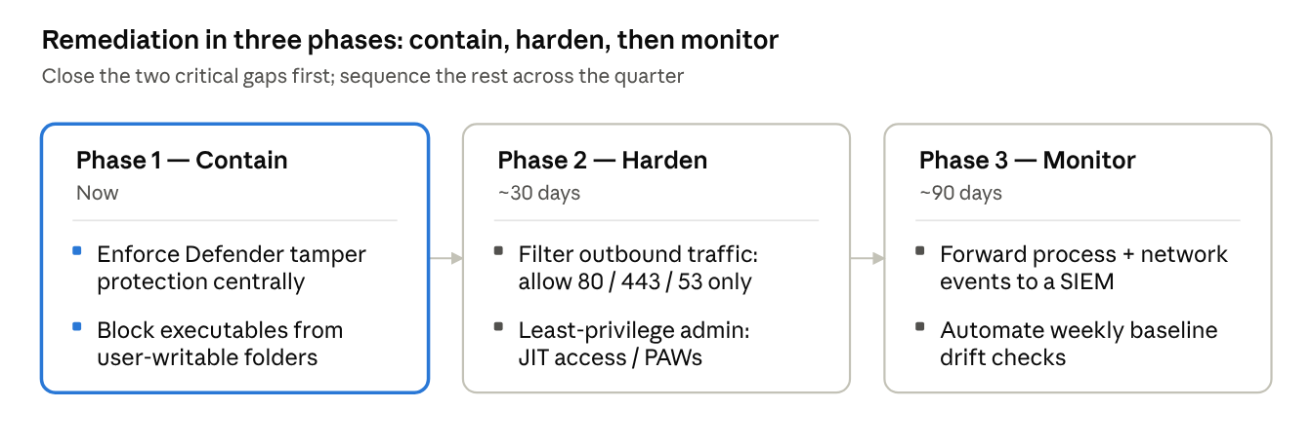
remediation roadmap · 3 phases
Timeframes are indicative — the assessment set Immediate, Short-term, and Strategic priorities; confirm the dates against your change calendar. The two Phase 1 items close the critical gaps and should not wait.

Decisions needed
The assessment is a lab result; moving it into production practice needs three decisions from leadership.
- Approve the Phase 1 lockdown now. Centrally enforcing tamper protection and blocking executables from user folders closes the critical gaps, but will restrict what local administrators can do. Confirm you accept that trade-off.
- Assign an owner and a date to each phase. The plan has none yet. Suggested split: Phase 1 to endpoint/platform, Phase 2 to network, Phase 3 to security operations.
- Fund SIEM ingestion. Phase 3 turns the detection this exercise proved into standing alerts, but needs log forwarding and a SIEM to land in. Decide whether that budget is in scope this quarter.
Once these are confirmed, the roadmap above can become a dated, owner-assigned plan.

